[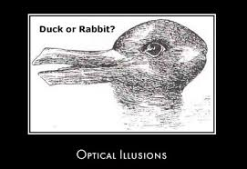](http://www.google.com/url?sa=i&rct=j&q=&esrc=s&source=images&cd=&cad=rja&uact=8&docid=Dzq3uCOQmIQClM&tbnid=VtLg_WtdnUxBPM:&ved=0CAUQjRw&url=http%3A%2F%2Fwww.all-about-psychology.com%2Foptical-illusions.html&ei=CS8DVIqZCs6myATgyoCAAw&bvm=bv.74115972,d.eXY&psig=AFQjCNEkpFrPEAjE1riazv8YPkoycGNLHA&ust=1409581145058426)

[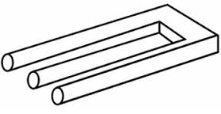](http://www.google.com/imgres?imgurl=http%3A%2F%2Fi1.wp.com%2Flistverse.com%2Fwp-content%2Fuploads%2F2007%2F09%2Fpic-blivet.jpg&imgrefurl=http%3A%2F%2Flistverse.com%2F2007%2F09%2F16%2F20-amazing-optical-illusions%2F&h=180&w=348&tbnid=u2jVm2vsK2kvdM%3A&zoom=1&docid=lg_Y0LGVqWFXKM&ei=2C4DVNXWLpa8ggTa6YGQDA&tbm=isch&ved=0CJIBEDMoUTBR&iact=rc&uact=3&dur=611&page=4&start=78&ndsp=32)

[](http://www.google.com/imgres?imgurl=http%3A%2F%2Fcdn.instantshift.com%2Fmedia%2Fuploads%2F2012%2F12%2Foptical-illusions-in-design.jpg&imgrefurl=http%3A%2F%2Fwww.instantshift.com%2F2012%2F12%2F21%2Foptical-illusions-in-design%2F&h=340&w=500&tbnid=AmU7t5khNJ2VbM%3A&zoom=1&docid=yEWI7IQTcEC1-M&ei=KzUDVM_TD5GmggTqm4LQDw&tbm=isch&ved=0CDUQMygtMC04yAE&iact=rc&uact=3&dur=523&page=9&start=239&ndsp=30)[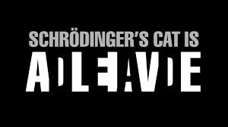](http://www.google.com/imgres?imgurl=http%3A%2F%2Fhqwallbase.com%2Fimages%2Fbigest%2F1920x1080_Optical-Illusions-Wallpaper-1440x900.jpg&imgrefurl=http%3A%2F%2Fhqwallbase.com%2F32622-optical-illusions-wallpaper-1440x900%2F&h=1080&w=1920&tbnid=8iwwHe9LpySLXM%3A&zoom=1&docid=IBgE3IFoHge6qM&ei=KzUDVM_TD5GmggTqm4LQDw&tbm=isch&ved=0CD0QMyg1MDU4yAE&iact=rc&uact=3&dur=992&page=9&start=239&ndsp=30)[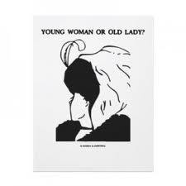](http://www.google.com/url?sa=i&rct=j&q=&esrc=s&source=images&cd=&cad=rja&uact=8&docid=eiaP43CJMFi0FM&tbnid=H9LfSisaBIruCM:&ved=0CAUQjRw&url=http%3A%2F%2Fblogs.ucl.ac.uk%2Fevents%2Ftag%2Foptical-illusions%2F&ei=ejQDVMH9LJSuyATQsYDYBQ&bvm=bv.74115972,d.eXY&psig=AFQjCNEkpFrPEAjE1riazv8YPkoycGNLHA&ust=1409581145058426)[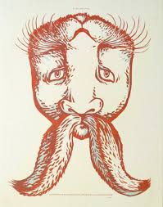](http://www.google.com/imgres?imgurl=http%3A%2F%2Ffuneyetest.com%2Fwp-content%2Fuploads%2F2014%2F05%2Ffunny-optical-optical-illusions-duck-or-rabbit-131.jpg&imgrefurl=http%3A%2F%2Ffuneyetest.com%2Ffunny-optical-optical-illusions-duck-or-rabbit%2F&h=541&w=425&tbnid=bCdGw2YQ1zaawM%3A&zoom=1&docid=SQ5tMoL9m688bM&ei=2C4DVNXWLpa8ggTa6YGQDA&tbm=isch&ved=0CKABEDMoXzBf&iact=rc&uact=3&dur=572&page=4&start=78&ndsp=32)

Look at the yellow dots…Which is bigger?